**Worksheet 4 Name _______ANSWERS__________________ _____**

**61**

**MCSE 1**

1. Name the 5 data grams of the OSI model and indicate which layer (by name, not number) each data gram is associated with?

[5] Mnemonic: **D**o **S**ex **P**uppets **F**uck **B**oys?

**D**ata: Application, Presentation, Session

**S**egment: Transport

**P**ackets: Network

**F**rame: Data Link

**B**its: Physical

2. For each of the following protocols, indicate which layer (by name), of the OSI model it is associated with?

[10] TCP = **__**Port -> Transport___DNS = **___________________**

PPP = **___________________** Half duplex = **___________________**

HTTP = **___**Application**_______** ICMP = **_____**Network**______**

DHCP = **___**Application**______** FTP = **____**Application**_____**

MIME = **___________________** IP = **____** Network **_______**

ARP = **___**Data Link**_______** UDP = **___________________**

IPSec = **___________________** SMTP = **___________________**

Telnet = **___________________** POP = **___________________**

PPTP = **___________________** NetBIOS = **___________________**

SSL = **___________________** L2TP = **___________________**

3. List 3 types of addressing each frame contains. Opposite each address type indicate at which layer of the OSI model it is added to the frame. Assume the network is a LAN using Ethernet

[3] Transport Layer Addressing (ports) – 16bits uint

Network Addressing (IP Address) – 32bits uint

Data Link Addressing (Physical Addressing) – 48bits uint

4. Which port number is used for WEB services?

[1] 80

5. What is the purpose of the port numbers?

[2] Port number determines which application will get the frames

6. How is a source port number determined?

[2] Host computer randomly generates the source port numbers

7. What is the range of source port numbers?

[2] 2^10 – 2^16

8. What are the two main functions of the network layer?

[2] Assign IP address and route packets between networks

9. What is the purpose of the CRC found in the trailer of each frame?

[1] Error correction

10. What type of layer 2 addressing does frame relay use?

[1] DLCI

11. How is a MAC addresses assigned to a computer?

[2] Through the Network Interface Card

12. How is the frame relay address assigned to a computer?

[2]

13. How does a host decide if it should send the frame to a host on the same segment as itself or send it to the gateway?

[3]

14. How many bits are there in a MAC address?

[1]

15. How many bits are there in an IPv4 address?

[1]

16. How many bits are there in a port number?

[1]

17. If the MAC table is empty, how does a host find the MAC address of the destination host?

[1]

18. What do you type at the DOS prompt to see the contents of the MAC table?

[1]

19. What important information is found in the MAC table?

[2]

20. What is the advantage of having an ARP cache?

[1]

21. Explain what a router does to deliver a frame when it receives a frame on an Ethernet interface?

[4]

22. List the layers in the TCP/IP model.

[2]

23. Represent the IP address 157.62.115.87/19 in binary. Below that binary number, put the subnet mask in binary. AND the two binary numbers together to get the network number in binary. Then convert the binary network number into a dotted decimal network number.

[4]

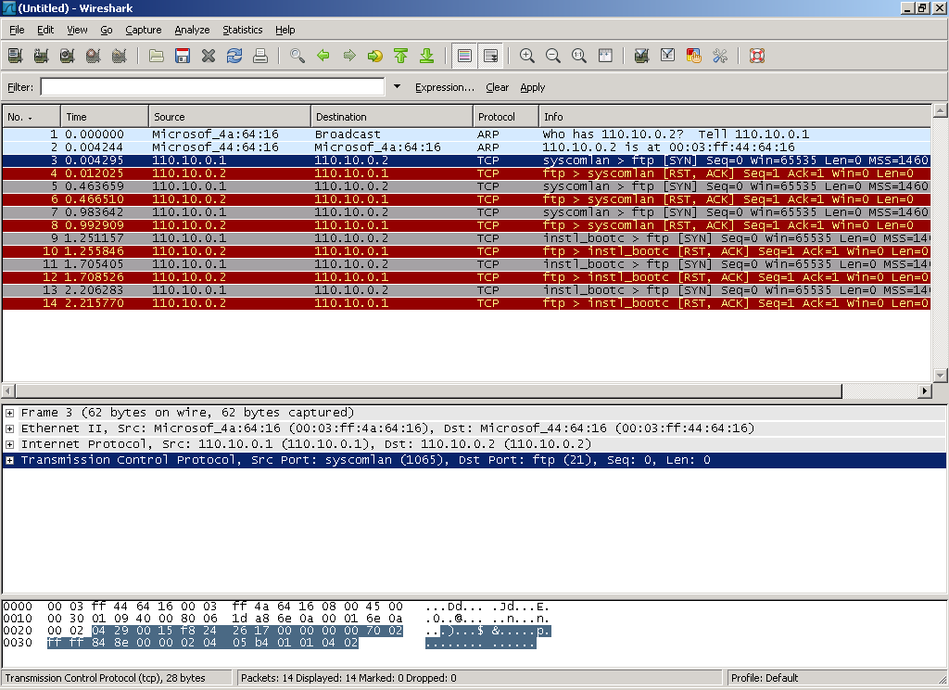

24. Draw an Ethernet frame as shown in figure 5 of the lecture notes for the 3rd frame shown above. Make sure the actual numbers for the 3 types of [7] addresses appear in your frame. Label each frame as source/destination as well as the name of the address; ie. port, IP, or MAC.